Part-A: SSP
1. Is the complete design functional (FIFOs, Logic)?
Yes

2. Synthesis Results
Loading verilog files: '/home/ecelrc/students/jzhang11/vlsi1/lab3/RXFIFO.v' '/home/ecelrc/students/jzhang11/vlsi1/lab3/SSP.v' '/home/ecelrc/students/jzhang11/vlsi1/lab3/TXFIFO.v' '/home/ecelrc/students/jzhang11/vlsi1/lab3/TR.v'
Detecting input file type automatically (-rtl or -netlist).
Reading with Presto HDL Compiler (equivalent to -rtl option).
Running PRESTO HDLC
Compiling source file /home/ecelrc/students/jzhang11/vlsi1/lab3/RXFIFO.v
Compiling source file /home/ecelrc/students/jzhang11/vlsi1/lab3/SSP.v
Compiling source file /home/ecelrc/students/jzhang11/vlsi1/lab3/TXFIFO.v
Compiling source file /home/ecelrc/students/jzhang11/vlsi1/lab3/TR.v

Statistics for case statements in always block at line 22 in file
'/home/ecelrc/students/jzhang11/vlsi1/lab3/RXFIFO.v'
===============================================
| Line | full/ parallel |
===============================================
| 26 | auto/auto |
===============================================

Statistics for case statements in always block at line 46 in file
'/home/ecelrc/students/jzhang11/vlsi1/lab3/RXFIFO.v'
===============================================
| Line | full/ parallel |
===============================================
| 49 | auto/auto |
===============================================

Inferred memory devices in process
in routine RXFIFO line 22 in file
'/home/ecelrc/students/jzhang11/vlsi1/lab3/RXFIFO.v'.
===============================================================================
| Register Name | Type | Width | Bus | MB | AR | AS | SR | SS | ST |
===============================================================================
| data_reg | Flip-flop | 32 | Y | N | N | N | N | N | N |
| write_pt_reg | Flip-flop | 3 | Y | N | N | N | N | N | N |
| NOTFULL_reg | Flip-flop | 1 | N | N | N | N | N | N | N |
===============================================================================

Inferred memory devices in process
in routine RXFIFO line 46 in file
'/home/ecelrc/students/jzhang11/vlsi1/lab3/RXFIFO.v'.
===================================================================================
| Register Name | Type | Width | Bus | MB | AR | AS | SR | SS | ST |
===================================================================================
| bus_data_reg | Flip-flop | 8 | Y | N | N | N | N | N | N |
| bus_data_tri_enable_reg | Flip-flop | 8 | Y | N | N | N | N | N | N |
| enable_reg | Flip-flop | 1 | N | N | N | N | N | N | N |
| read_pt_reg | Flip-flop | 3 | Y | N | N | N | N | N | N |
===================================================================================

Inferred tri-state devices in process
in routine RXFIFO line 19 in file
'/home/ecelrc/students/jzhang11/vlsi1/lab3/RXFIFO.v'.
============================================
| Register Name | Type | Width |
============================================
| PRDATA_tri | Tri-State Buffer | 8 |
============================================

Inferred tri-state devices in process
in routine RXFIFO line 46 in file
'/home/ecelrc/students/jzhang11/vlsi1/lab3/RXFIFO.v'.
============================================
| Register Name | Type | Width |
============================================
| bus_data_tri | Tri-State Buffer | 8 |
============================================

Statistics for case statements in always block at line 25 in file
'/home/ecelrc/students/jzhang11/vlsi1/lab3/TXFIFO.v'
===============================================
| Line | full/ parallel |
===============================================
| 28 | auto/auto |
===============================================

Statistics for case statements in always block at line 47 in file
'/home/ecelrc/students/jzhang11/vlsi1/lab3/TXFIFO.v'
===============================================
| Line | full/ parallel |
===============================================
| 50 | auto/auto |
===============================================

Inferred memory devices in process
in routine TXFIFO line 25 in file
'/home/ecelrc/students/jzhang11/vlsi1/lab3/TXFIFO.v'.
===============================================================================
| Register Name | Type | Width | Bus | MB | AR | AS | SR | SS | ST |
===============================================================================
| data_reg | Flip-flop | 32 | Y | N | N | N | N | N | N |
| write_pt_reg | Flip-flop | 3 | Y | N | N | N | N | N | N |
===============================================================================

Inferred memory devices in process
in routine TXFIFO line 47 in file
'/home/ecelrc/students/jzhang11/vlsi1/lab3/TXFIFO.v'.
===============================================================================
| Register Name | Type | Width | Bus | MB | AR | AS | SR | SS | ST |
===============================================================================
| read_pt_reg | Flip-flop | 3 | Y | N | N | N | N | N | N |
| TXDATA_reg | Flip-flop | 8 | Y | N | N | N | N | N | N |
===============================================================================

Inferred memory devices in process
in routine TR line 24 in file
'/home/ecelrc/students/jzhang11/vlsi1/lab3/TR.v'.
===============================================================================
| Register Name | Type | Width | Bus | MB | AR | AS | SR | SS | ST |
===============================================================================
| outdata_reg | Flip-flop | 8 | Y | N | N | N | N | N | N |
| outflag_reg | Flip-flop | 1 | N | N | N | N | N | N | N |
| READ_REQ_reg | Flip-flop | 1 | N | N | N | N | N | N | N |
| SSPTXD_reg | Flip-flop | 1 | N | N | N | N | N | N | N |
| outcount_reg | Flip-flop | 3 | Y | N | N | N | N | N | N |
| SSPCLKOUT_reg | Flip-flop | 1 | N | N | N | N | N | N | N |
| outnotp_reg | Flip-flop | 1 | N | N | N | N | N | N | N |
| count_reg | Flip-flop | 1 | N | N | N | N | N | N | N |
| clocked_reg | Flip-flop | 1 | N | N | N | N | N | N | N |
| SSPOE_B_reg | Flip-flop | 1 | N | N | N | N | N | N | N |
| SSPFSSOUT_reg | Flip-flop | 1 | N | N | N | N | N | N | N |
===============================================================================

Inferred memory devices in process
in routine TR line 90 in file
'/home/ecelrc/students/jzhang11/vlsi1/lab3/TR.v'.
===============================================================================
| Register Name | Type | Width | Bus | MB | AR | AS | SR | SS | ST |
===============================================================================
| incount_reg | Flip-flop | 3 | Y | N | N | N | N | N | N |
| inflag_reg | Flip-flop | 1 | N | N | N | N | N | N | N |
| newdflag_reg | Flip-flop | 1 | N | N | N | N | N | N | N |
| indata_reg | Flip-flop | 8 | Y | N | N | N | N | N | N |
===============================================================================

Inferred memory devices in process
in routine TR line 120 in file
'/home/ecelrc/students/jzhang11/vlsi1/lab3/TR.v'.
===============================================================================
| Register Name | Type | Width | Bus | MB | AR | AS | SR | SS | ST |
===============================================================================
| NEW_DATA_reg | Flip-flop | 1 | N | N | N | N | N | N | N |
| RXDATA_reg | Flip-flop | 8 | Y | N | N | N | N | N | N |
===============================================================================
Presto compilation completed successfully.
Current design is now '/home/ecelrc/students/jzhang11/vlsi1/lab3/RXFIFO.db:RXFIFO'
Loaded 4 designs.
Current design is 'RXFIFO'.
design_vision>
Current design is 'RXFIFO'.
3. Brief description of the strategy used for design

TXFIFO grabs data on each rising edge and transfers to Transmit logic. TXFIFO/RXFIFO uses pointers to track where to read/write and determine full/empty. Transmit/receive logic uses a count to execute on SSPCLK. Receive logic will continuously attempt to write to RXFIFO until finished or new data received (from transmit).

Part-B: Wishbone
1. Is the design functional? – Yes
a) Can ARM read instructions from memory correctly? Yes
b) Is data written correctly to SSP? Yes
c) Is SSPTXINTR set to 1(0) when TxFIFO is full (not full)? Provided test never causes this condition, but yes.
d) Are phi1 & phi2 clocks stopped when there is an interrupt? Provided test never causes this condition, but should.
e) Are all the data written in SSP read back and saved at proper register locations?
Yes

2. Synthesis Result
Loading verilog files: '/home/ecelrc/students/jzhang11/vlsi1/lab3/rtl/w_slave.v' '/home/ecelrc/students/jzhang11/vlsi1/lab3/rtl/w_master.v' '/home/ecelrc/students/jzhang11/vlsi1/lab3/rtl/wishbone.v' '/home/ecelrc/students/jzhang11/vlsi1/lab3/rtl/cmu.v'
Detecting input file type automatically (-rtl or -netlist).
Reading with Presto HDL Compiler (equivalent to -rtl option).
Running PRESTO HDLC
Compiling source file /home/ecelrc/students/jzhang11/vlsi1/lab3/rtl/w_slave.v
Warning: /home/ecelrc/students/jzhang11/vlsi1/lab3/rtl/w_slave.v:18: The value 00010001 is too large for the numeric data type being used (VER-1)
Warning: /home/ecelrc/students/jzhang11/vlsi1/lab3/rtl/w_slave.v:22: The value 00010001 is too large for the numeric data type being used (VER-1)
Warning: /home/ecelrc/students/jzhang11/vlsi1/lab3/rtl/w_slave.v:65: The value 00010001 is too large for the numeric data type being used (VER-1)
Warning: /home/ecelrc/students/jzhang11/vlsi1/lab3/rtl/w_slave.v:66: The value 00010001 is too large for the numeric data type being used (VER-1)
Compiling source file /home/ecelrc/students/jzhang11/vlsi1/lab3/rtl/w_master.v
Compiling source file /home/ecelrc/students/jzhang11/vlsi1/lab3/rtl/wishbone.v
Warning: /home/ecelrc/students/jzhang11/vlsi1/lab3/rtl/wishbone.v:24: the undeclared symbol 'mem_req_bar' assumed to have the default net type, which is 'wire'. (VER-936)
Warning: /home/ecelrc/students/jzhang11/vlsi1/lab3/rtl/wishbone.v:24: the undeclared symbol 'mem_write_read' assumed to have the default net type, which is 'wire'. (VER-936)
Warning: /home/ecelrc/students/jzhang11/vlsi1/lab3/rtl/wishbone.v:26: the undeclared symbol 'r' assumed to have the default net type, which is 'wire'. (VER-936)
Warning: /home/ecelrc/students/jzhang11/vlsi1/lab3/rtl/wishbone.v:26: the undeclared symbol 'w' assumed to have the default net type, which is 'wire'. (VER-936)
Compiling source file /home/ecelrc/students/jzhang11/vlsi1/lab3/rtl/cmu.v

Statistics for case statements in always block at line 14 in file
'/home/ecelrc/students/jzhang11/vlsi1/lab3/rtl/w_slave.v'
===============================================
| Line | full/ parallel |
===============================================
| 15 | auto/auto |
===============================================

Statistics for case statements in always block at line 61 in file
'/home/ecelrc/students/jzhang11/vlsi1/lab3/rtl/w_slave.v'
===============================================
| Line | full/ parallel |
===============================================
| 62 | auto/auto |
===============================================

Inferred memory devices in process
in routine w_slave line 14 in file
'/home/ecelrc/students/jzhang11/vlsi1/lab3/rtl/w_slave.v'.
===============================================================================
| Register Name | Type | Width | Bus | MB | AR | AS | SR | SS | ST |
===============================================================================
| dat_o_reg | Flip-flop | 32 | Y | N | N | N | N | N | N |
| tagn_o_reg | Flip-flop | 1 | N | N | N | N | N | N | N |
| ssp_sel_o_reg | Flip-flop | 1 | N | N | N | N | N | N | N |
| ssp_w_o_reg | Flip-flop | 1 | N | N | N | N | N | N | N |
| mem_r_o_reg | Flip-flop | 1 | N | N | N | N | N | N | N |
| mem_w_o_reg | Flip-flop | 1 | N | N | N | N | N | N | N |
| ack_o_reg | Flip-flop | 1 | N | N | N | N | N | N | N |
===============================================================================

Inferred memory devices in process
in routine w_slave line 61 in file
'/home/ecelrc/students/jzhang11/vlsi1/lab3/rtl/w_slave.v'.
===============================================================================
| Register Name | Type | Width | Bus | MB | AR | AS | SR | SS | ST |
===============================================================================
| state_reg | Flip-flop | 3 | Y | N | N | N | N | N | N |
===============================================================================

Inferred tri-state devices in process
in routine w_slave line 12 in file
'/home/ecelrc/students/jzhang11/vlsi1/lab3/rtl/w_slave.v'.
============================================
| Register Name | Type | Width |
============================================
| dataBus_tri | Tri-State Buffer | 32 |
============================================

Statistics for case statements in always block at line 18 in file
'/home/ecelrc/students/jzhang11/vlsi1/lab3/rtl/w_master.v'
===============================================
| Line | full/ parallel |
===============================================
| 19 | auto/auto |
===============================================

Statistics for case statements in always block at line 54 in file
'/home/ecelrc/students/jzhang11/vlsi1/lab3/rtl/w_master.v'
===============================================
| Line | full/ parallel |
===============================================
| 55 | auto/auto |
===============================================

Inferred memory devices in process
in routine w_master line 18 in file
'/home/ecelrc/students/jzhang11/vlsi1/lab3/rtl/w_master.v'.
===============================================================================
| Register Name | Type | Width | Bus | MB | AR | AS | SR | SS | ST |
===============================================================================
| we_o_reg | Flip-flop | 1 | N | N | N | N | N | N | N |
| cyc_o_reg | Flip-flop | 1 | N | N | N | N | N | N | N |
| adr_o_reg | Flip-flop | 26 | Y | N | N | N | N | N | N |
| data_reg | Flip-flop | 32 | Y | N | N | N | N | N | N |
| stb_o_reg | Flip-flop | 1 | N | N | N | N | N | N | N |
===============================================================================

Inferred memory devices in process
in routine w_master line 54 in file
'/home/ecelrc/students/jzhang11/vlsi1/lab3/rtl/w_master.v'.
===============================================================================
| Register Name | Type | Width | Bus | MB | AR | AS | SR | SS | ST |
===============================================================================
| state_reg | Flip-flop | 3 | Y | N | N | N | N | N | N |
===============================================================================

Inferred tri-state devices in process
in routine w_master line 15 in file
'/home/ecelrc/students/jzhang11/vlsi1/lab3/rtl/w_master.v'.
============================================
| Register Name | Type | Width |
============================================
| dataBus_tri | Tri-State Buffer | 32 |
============================================
Warning: /home/ecelrc/students/jzhang11/vlsi1/lab3/rtl/cmu.v:32: DEFAULT branch of CASE statement cannot be reached. (ELAB-311)

Statistics for case statements in always block at line 28 in file
'/home/ecelrc/students/jzhang11/vlsi1/lab3/rtl/cmu.v'
===============================================
| Line | full/ parallel |
===============================================
| 32 | auto/auto |
===============================================

Inferred memory devices in process
in routine cmu line 13 in file
'/home/ecelrc/students/jzhang11/vlsi1/lab3/rtl/cmu.v'.
===============================================================================
| Register Name | Type | Width | Bus | MB | AR | AS | SR | SS | ST |
===============================================================================
| phi1_reg | Flip-flop | 1 | N | N | N | N | N | N | N |
| phi2_reg | Flip-flop | 1 | N | N | N | N | N | N | N |
===============================================================================

Inferred memory devices in process
in routine cmu line 28 in file
'/home/ecelrc/students/jzhang11/vlsi1/lab3/rtl/cmu.v'.
===============================================================================
| Register Name | Type | Width | Bus | MB | AR | AS | SR | SS | ST |
===============================================================================
| state_reg | Flip-flop | 2 | Y | N | N | N | N | N | N |
===============================================================================
Presto compilation completed successfully.
Current design is now '/home/ecelrc/students/jzhang11/vlsi1/lab3/rtl/w_slave.db:w_slave'
Loaded 4 designs.
Current design is 'w_slave'.
design_vision>
Current design is 'w_slave'.3. Brief description of the strategy used for design
Wishbone master uses a state machine to constantly wait for new memory requests. Slave executes on falling clock edge. Order of execution for read is (stb = 1, slave signals memory/SSP, slave grabs memory and ack = 1, master puts data on databus and moves back to ready state). Order of execution for write is (stb = 1, master transfers data/address to slave, slave puts data on databus and signals appropriate memory/SSP, slave ack). CMU is also a state machine that outputs phi1 and phi2 with stop if TXINTR = 1.

Part-A
1. Waveform Results of ssp_test2.v
a. Make sure they are readable
b. Include SSP module’s input and output signals along with the contents of TxFIFO and RxFIFO
c. Multiple snapshots can be included if necessary

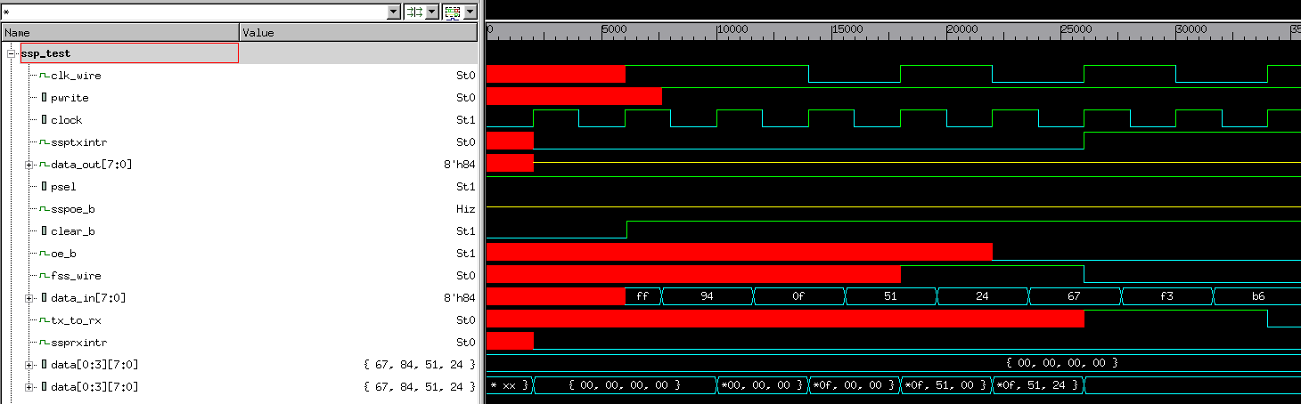
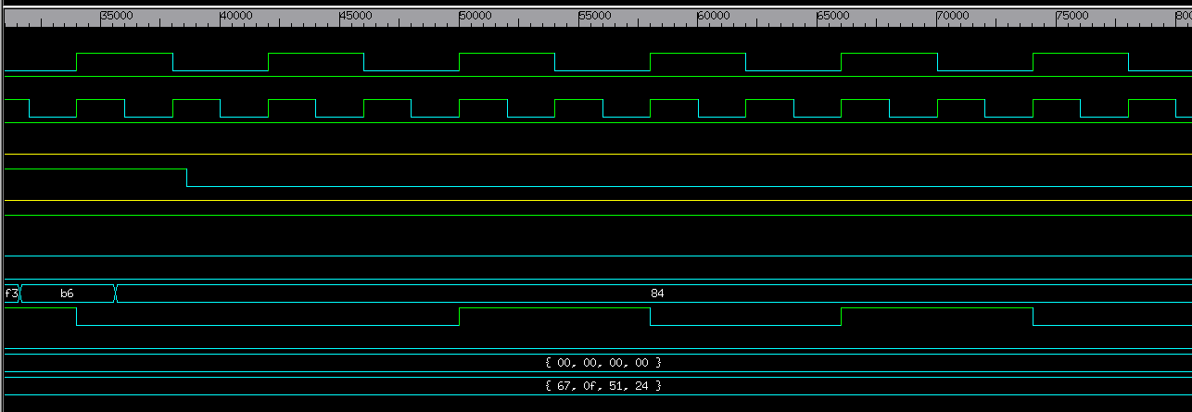
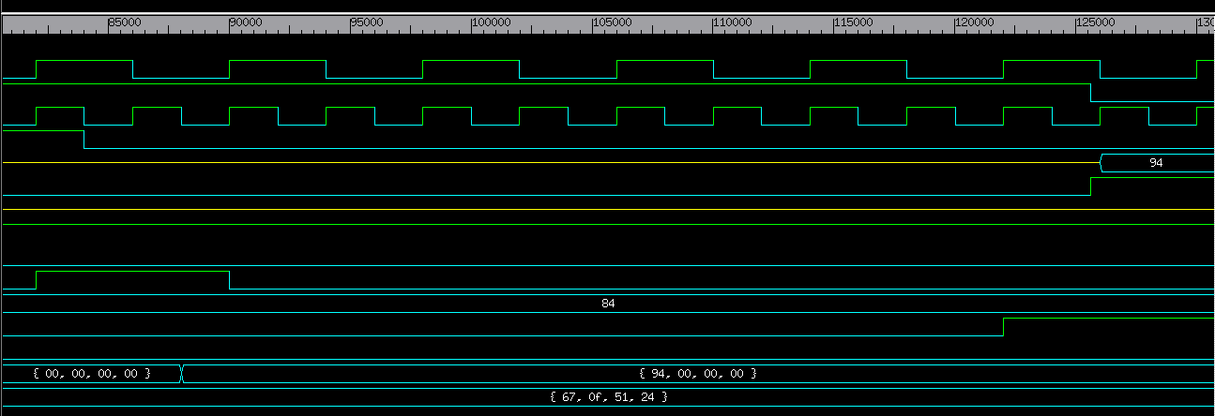
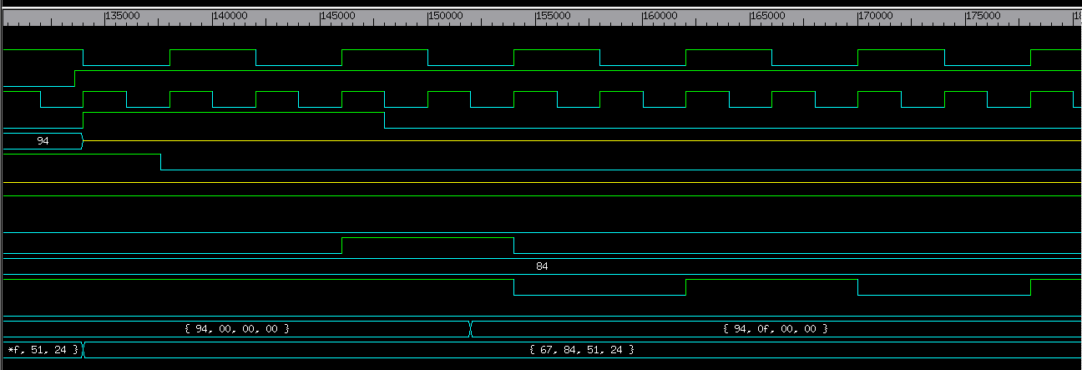
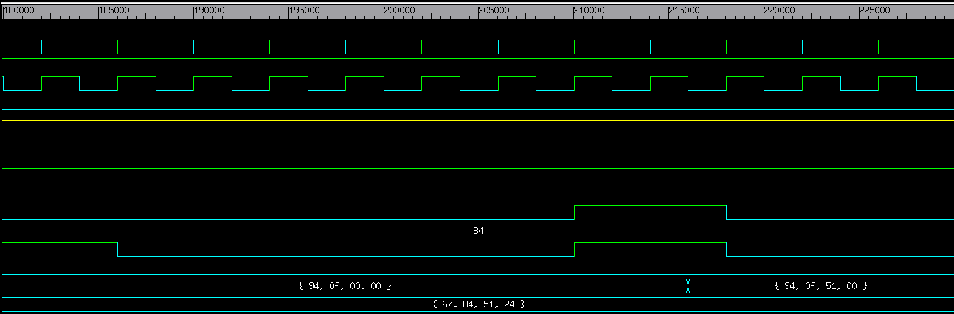
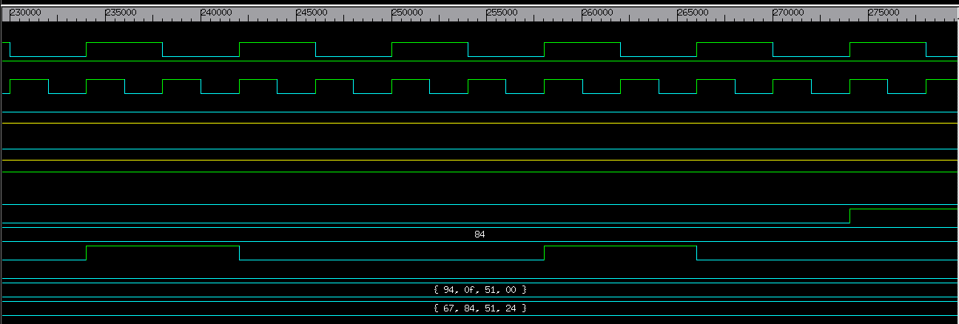
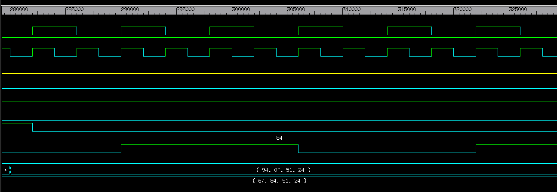
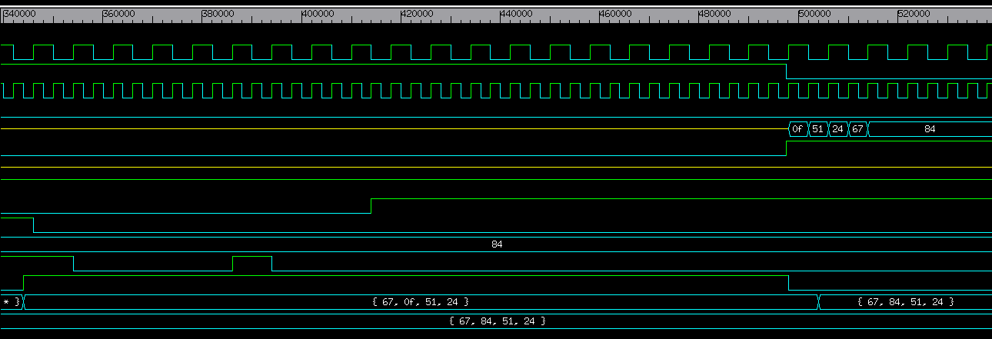
2. Synthesis Reports for all the 3 cases
****************************************
Report : area
Design : SSP
Version: P-2019.03-SP5
Date : Tue Oct 27 20:32:27 2020
****************************************

Library(s) Used:

gscl45nm (File: /usr/local/packages/cadence_2007/FreePDK45/osu_soc/lib/files/gscl45nm.db)

Number of ports: 104
Number of nets: 924
Number of cells: 837
Number of combinational cells: 699
Number of sequential cells: 135
Number of macros/black boxes: 0
Number of buf/inv: 329
Number of references: 3

Combinational area: 1546.812765
Buf/Inv area: 544.857287
Noncombinational area: 1077.043476
Macro/Black Box area: 0.000000
Net Interconnect area: undefined (No wire load specified)

Total cell area: 2623.856241
Total area: undefined

****************************************
Report : timing
-path full
-delay max
-max_paths 1
-sort_by group
Design : SSP
Version: P-2019.03-SP5
Date : Tue Oct 27 20:31:54 2020
****************************************

Operating Conditions: typical Library: gscl45nm
Wire Load Model Mode: top

Startpoint: rf/read_pt_reg[1]
(rising edge-triggered flip-flop clocked by vclk)
Endpoint: rf/data_reg[3][0]
(falling edge-triggered flip-flop clocked by vclk)
Path Group: vclk
Path Type: max

Point Incr Path
-----------------------------------------------------------
clock vclk (rise edge) 0.00 0.00
clock network delay (ideal) 0.00 0.00
rf/read_pt_reg[1]/CLK (DFFPOSX1) 0.00 0.00 r
rf/read_pt_reg[1]/Q (DFFPOSX1) 0.11 0.11 f
rf/U245/Y (INVX1) 0.04 0.14 r
rf/U174/Y (XOR2X1) 0.06 0.20 r
rf/U173/Y (NAND3X1) 0.02 0.22 f
rf/U211/Y (BUFX2) 0.04 0.26 f
rf/U167/Y (NAND3X1) 0.03 0.29 r
rf/U62/Y (BUFX2) 0.04 0.33 r
rf/U221/Y (INVX1) 0.04 0.37 f
rf/U159/Y (NAND3X1) 0.04 0.41 r
rf/U157/Y (BUFX2) 0.04 0.45 r
rf/U66/Y (AND2X1) 0.10 0.54 r
rf/U70/Y (INVX1) 0.04 0.59 f
rf/U11/Y (AND2X1) 0.04 0.63 f
rf/U200/Y (INVX1) 0.07 0.70 r
rf/U155/Y (OAI21X1) 0.03 0.73 f
rf/data_reg[3][0]/D (DFFNEGX1) 0.00 0.73 f
data arrival time 0.73

clock vclk (fall edge) 1000.00 1000.00
clock network delay (ideal) 0.00 1000.00
rf/data_reg[3][0]/CLK (DFFNEGX1) 0.00 1000.00 f
library setup time -0.35 999.65
data required time 999.65
-----------------------------------------------------------
data required time 999.65
data arrival time -0.73
-----------------------------------------------------------
slack (MET) 998.92
- Area reports
****************************************
Report : area
Design : SSP
Version: P-2019.03-SP5
Date : Tue Oct 27 20:34:38 2020
****************************************

Library(s) Used:

gscl45nm (File: /usr/local/packages/cadence_2007/FreePDK45/osu_soc/lib/files/gscl45nm.db)

Number of ports: 104
Number of nets: 917
Number of cells: 830
Number of combinational cells: 692
Number of sequential cells: 135
Number of macros/black boxes: 0
Number of buf/inv: 319
Number of references: 3

Combinational area: 1540.242565
Buf/Inv area: 533.594087
Noncombinational area: 1077.043476
Macro/Black Box area: 0.000000
Net Interconnect area: undefined (No wire load specified)

Total cell area: 2617.286041
Total area: undefined

****************************************
Report : timing
-path full
-delay max
-max_paths 1
-sort_by group
Design : SSP
Version: P-2019.03-SP5
Date : Tue Oct 27 20:36:03 2020
****************************************

Operating Conditions: typical Library: gscl45nm
Wire Load Model Mode: top

Startpoint: rf/read_pt_reg[0]
(rising edge-triggered flip-flop clocked by vclk)
Endpoint: rf/data_reg[1][0]
(falling edge-triggered flip-flop clocked by vclk)
Path Group: vclk
Path Type: max

Point Incr Path
-----------------------------------------------------------
clock vclk (rise edge) 0.00 0.00
clock network delay (ideal) 0.00 0.00
rf/read_pt_reg[0]/CLK (DFFPOSX1) 0.00 0.00 r
rf/read_pt_reg[0]/Q (DFFPOSX1) 0.12 0.12 f
rf/U166/Y (XNOR2X1) 0.06 0.18 r
rf/U154/Y (NAND3X1) 0.02 0.20 f
rf/U114/Y (BUFX2) 0.03 0.23 f
rf/U112/Y (INVX1) 0.00 0.23 r
rf/U16/Y (OR2X1) 0.05 0.28 r
rf/U15/Y (OR2X1) 0.08 0.36 r
rf/U224/Y (INVX1) 0.06 0.42 f
rf/U129/Y (NAND3X1) 0.04 0.45 r
rf/U124/Y (BUFX2) 0.04 0.49 r
rf/U116/Y (AND2X1) 0.10 0.59 r
rf/U118/Y (INVX1) 0.04 0.63 f
rf/U11/Y (AND2X1) 0.04 0.67 f
rf/U207/Y (INVX1) 0.07 0.74 r
rf/U111/Y (OAI21X1) 0.03 0.77 f
rf/data_reg[1][0]/D (DFFNEGX1) 0.00 0.77 f
data arrival time 0.77

clock vclk (fall edge) 1000.00 1000.00
clock network delay (ideal) 0.00 1000.00
rf/data_reg[1][0]/CLK (DFFNEGX1) 0.00 1000.00 f
library setup time -0.34 999.66
data required time 999.66
-----------------------------------------------------------
data required time 999.66
data arrival time -0.77
-----------------------------------------------------------
slack (MET) 998.88

- Timing reports
****************************************
Report : area
Design : SSP
Version: P-2019.03-SP5
Date : Tue Oct 27 20:45:46 2020
****************************************

Library(s) Used:

gscl45nm (File: /usr/local/packages/cadence_2007/FreePDK45/osu_soc/lib/files/gscl45nm.db)

Number of ports: 104
Number of nets: 949
Number of cells: 862
Number of combinational cells: 724
Number of sequential cells: 135
Number of macros/black boxes: 0
Number of buf/inv: 349
Number of references: 3

Combinational area: 1613.453365
Buf/Inv area: 582.870587
Noncombinational area: 1077.043476
Macro/Black Box area: 0.000000
Net Interconnect area: undefined (No wire load specified)

Total cell area: 2690.496841
Total area: undefined

****************************************
Report : timing
-path full
-delay max
-max_paths 1
-sort_by group
Design : SSP
Version: P-2019.03-SP5
Date : Tue Oct 27 20:44:55 2020
****************************************

Operating Conditions: typical Library: gscl45nm
Wire Load Model Mode: top

Startpoint: rf/read_pt_reg[1]
(rising edge-triggered flip-flop clocked by vclk)
Endpoint: rf/data_reg[1][0]
(falling edge-triggered flip-flop clocked by vclk)
Path Group: vclk
Path Type: max

Point Incr Path
-----------------------------------------------------------
clock vclk (rise edge) 0.00 0.00
clock network delay (ideal) 0.00 0.00
rf/read_pt_reg[1]/CLK (DFFPOSX1) 0.00 0.00 r
rf/read_pt_reg[1]/Q (DFFPOSX1) 0.11 0.11 f
rf/U239/Y (XNOR2X1) 0.03 0.14 f
rf/U173/Y (NAND3X1) 0.03 0.17 r
rf/U103/Y (BUFX2) 0.04 0.21 r
rf/U148/Y (AND2X2) 0.03 0.25 r
rf/U7/Y (AND2X2) 0.03 0.28 r
rf/U6/Y (INVX1) 0.03 0.31 f
rf/U91/Y (OAI21X1) 0.04 0.35 r
rf/U24/Y (INVX2) 0.03 0.38 f
rf/U163/Y (AND2X2) 0.04 0.41 f
rf/U164/Y (INVX1) 0.00 0.41 r
rf/U119/Y (OAI21X1) 0.01 0.42 f
rf/data_reg[1][0]/D (DFFNEGX1) 0.00 0.42 f
data arrival time 0.42

clock vclk (fall edge) 0.77 0.77
clock network delay (ideal) 0.00 0.77
rf/data_reg[1][0]/CLK (DFFNEGX1) 0.00 0.77 f
library setup time -0.35 0.42
data required time 0.42
-----------------------------------------------------------
data required time 0.42
data arrival time -0.42
-----------------------------------------------------------
slack (MET) 0.00

Part-B
1. Waveform Results
a. Make sure they are readable
b. Snapshots to be included
i. Waveform with register contents (R0 to R7) and arm core signals (phi1, phi2, clear, dataBus, addresBus, memoryRead & memoryWrite) – Entire simulation period
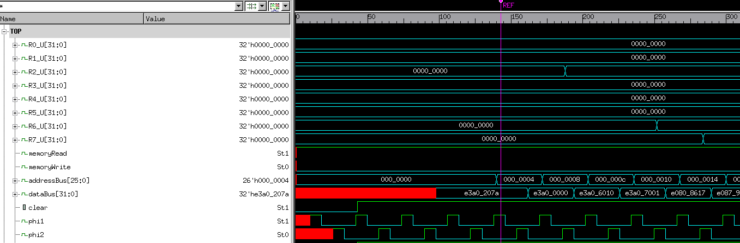
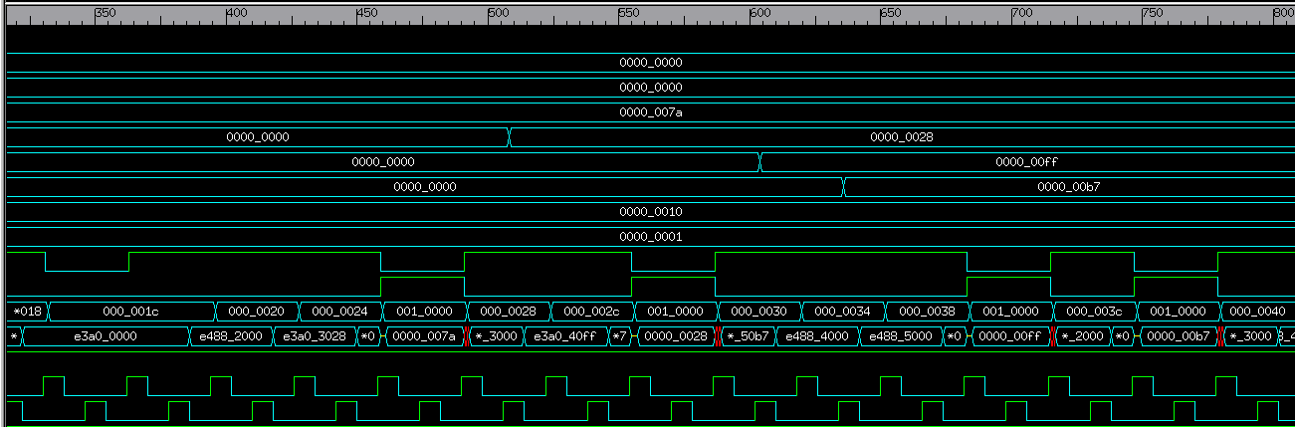

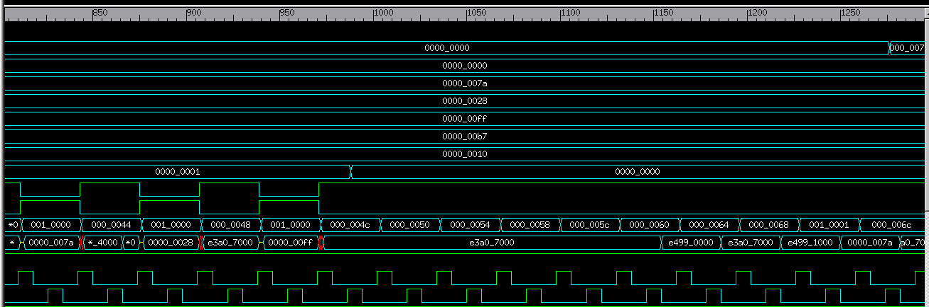
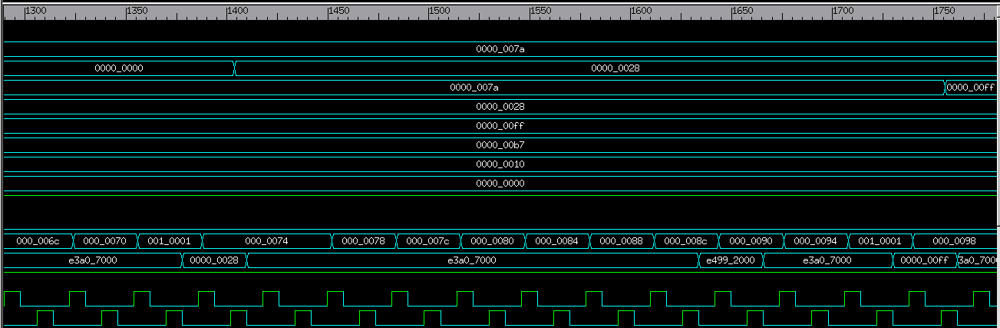
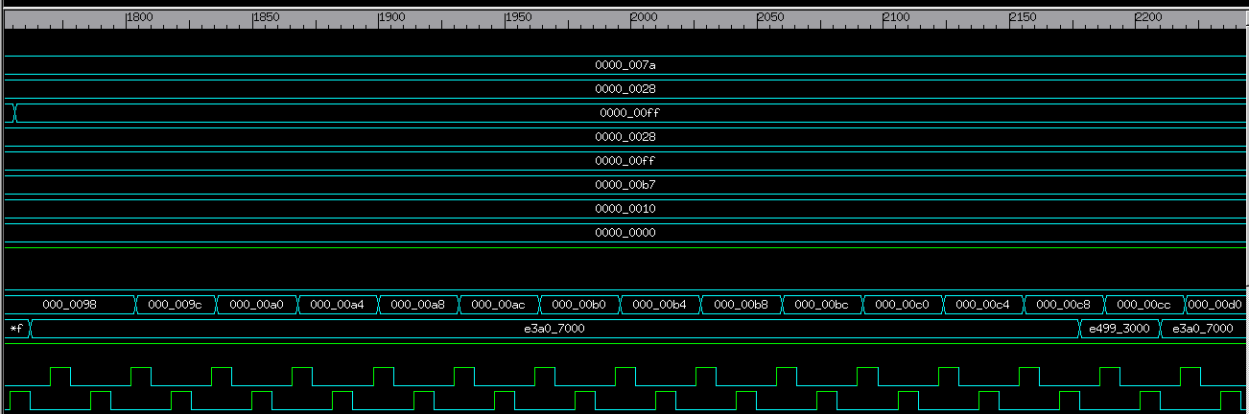
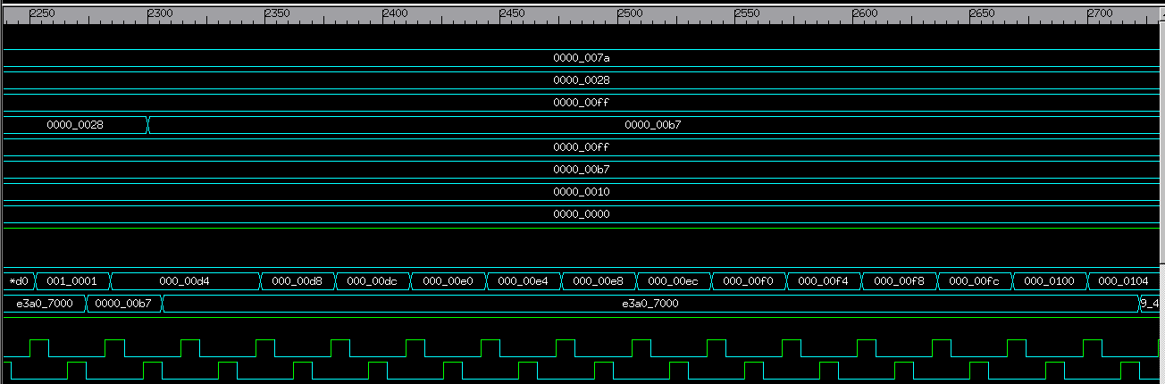
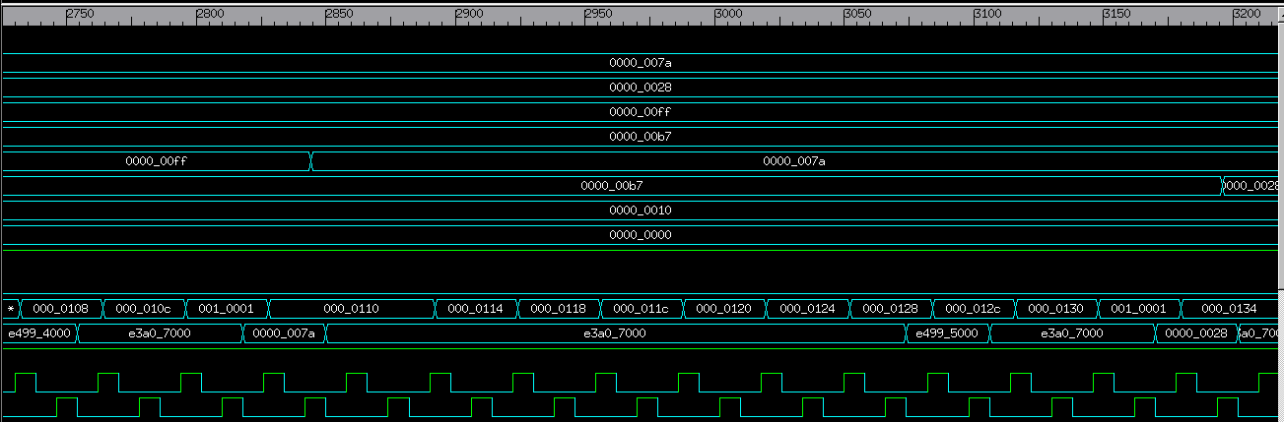
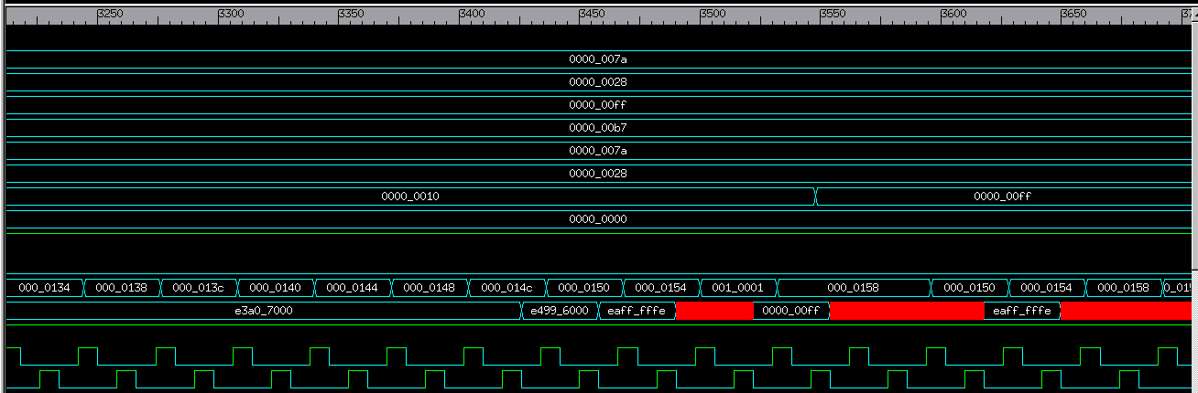
ii. Waveform with wishbone master’s input and output signals – Zoom in the relevant time periods, that is, when memory reads or SSP reads/writes are performed.
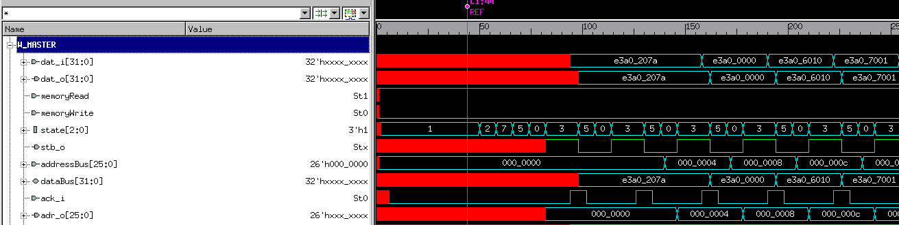
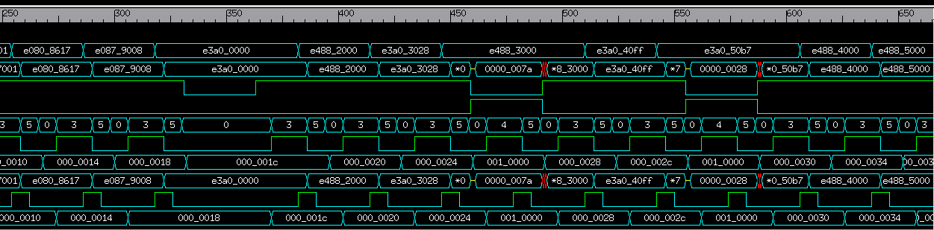
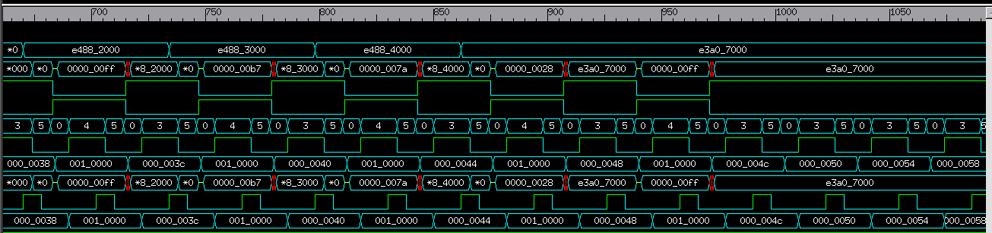
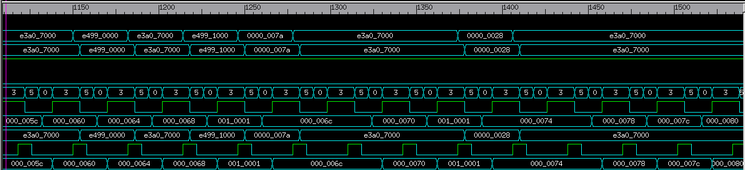
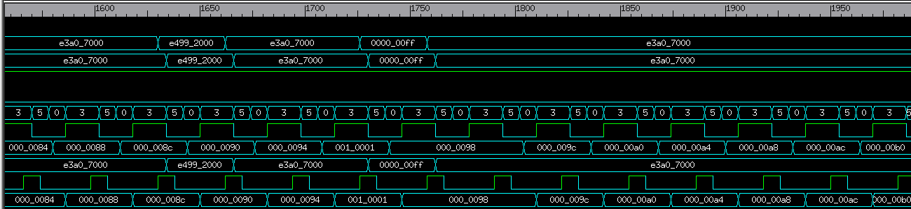
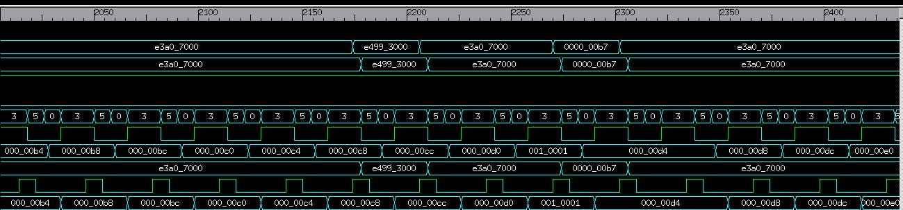
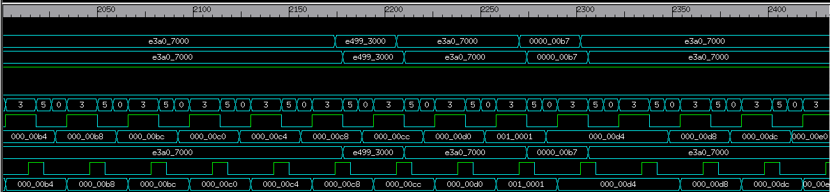
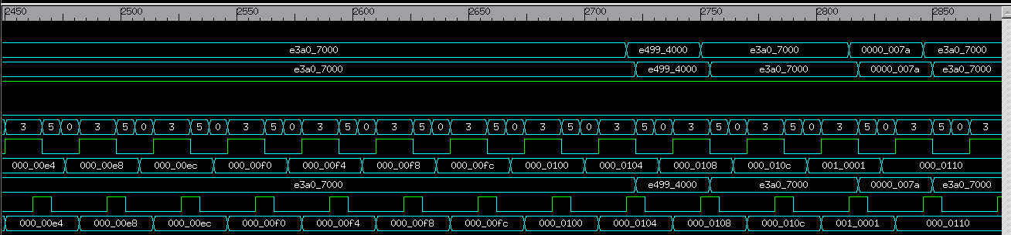
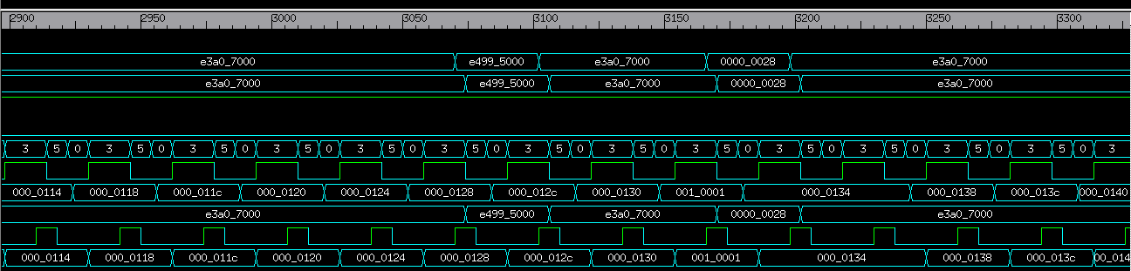
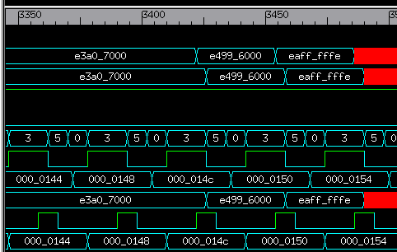
iii. Waveform with wishbone slave’s input and output signals – Zoom in the relevant time periods, that is, when memory reads or SSP reads/writes are performed.
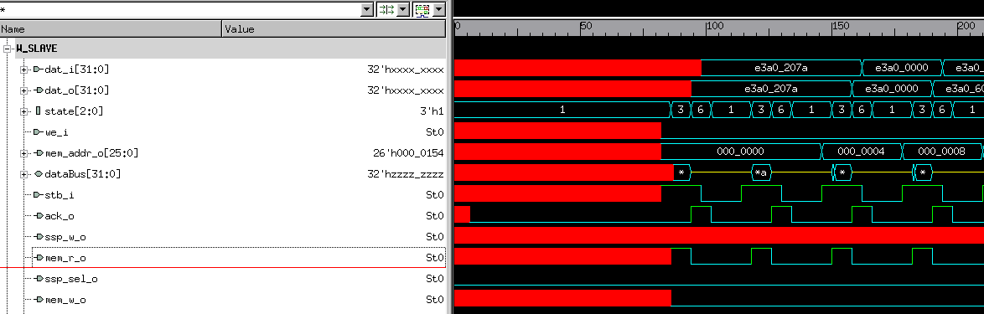
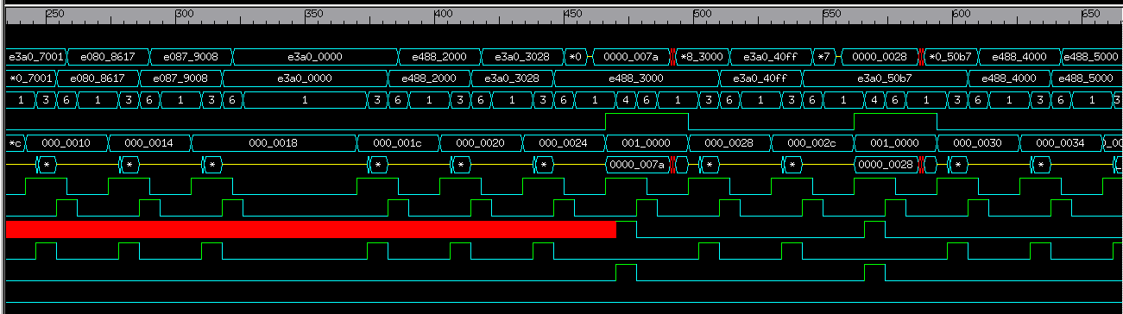

iv. Clock management unit – Entire simulation period
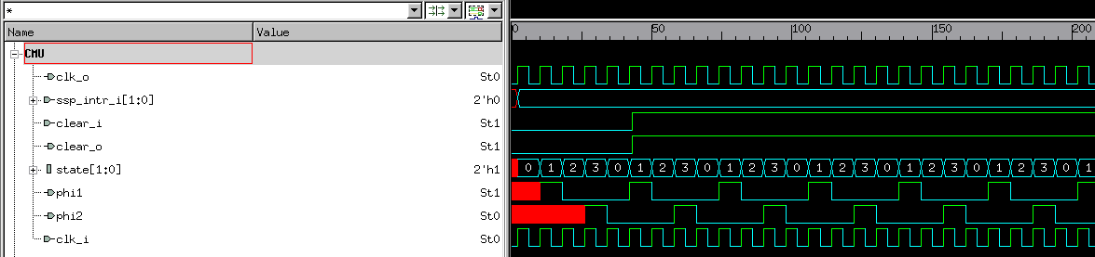
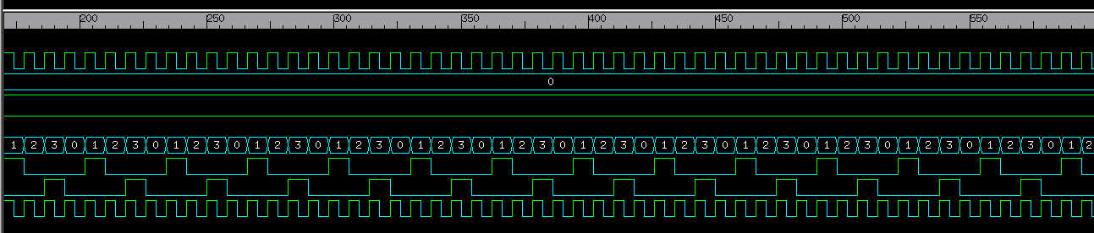
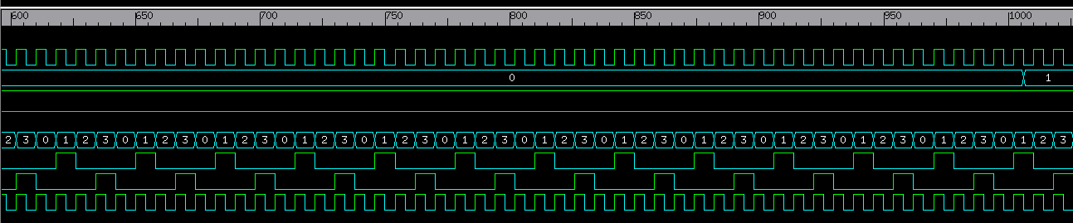
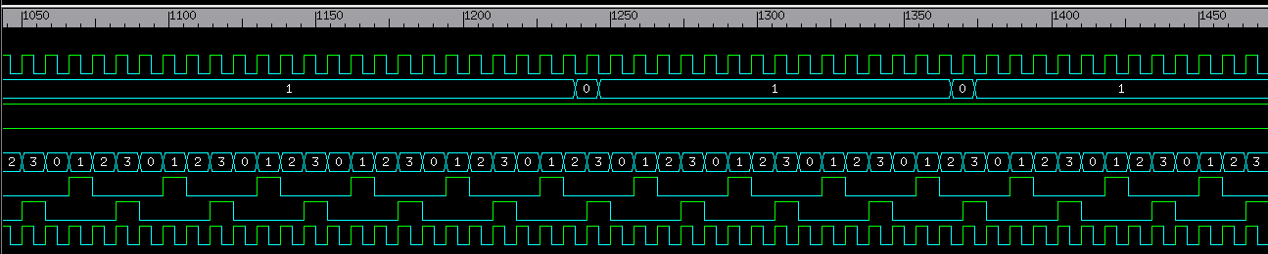
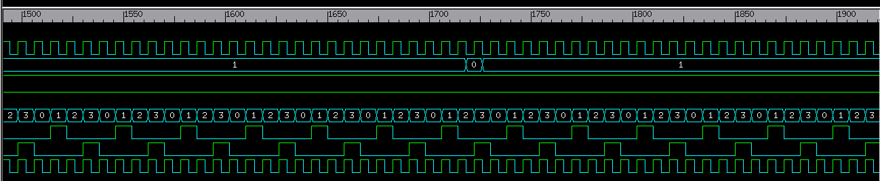
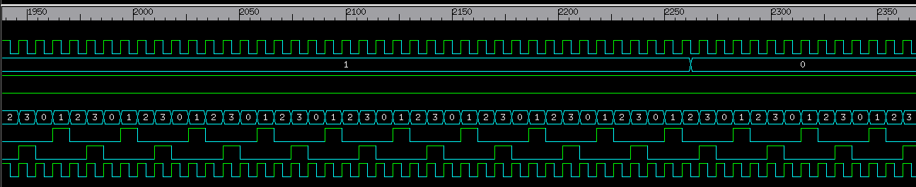
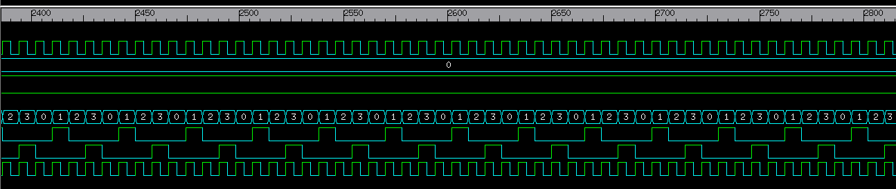
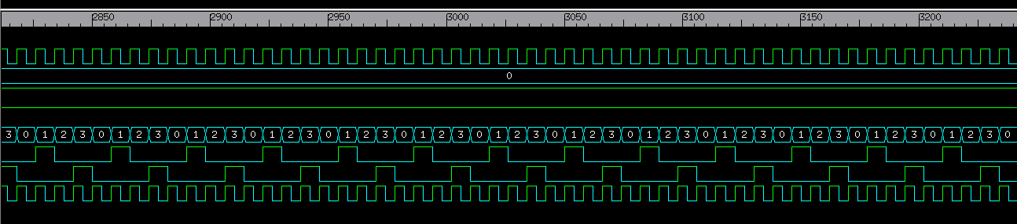
2. Synthesis Reports for all the 3 cases
****************************************
Report : area
Design : wishbone
Version: P-2019.03-SP5
Date : Sun Nov 1 11:29:02 2020
****************************************

Information: Updating design information... (UID-85)
Library(s) Used:

gscl45nm (File: /usr/local/packages/cadence_2007/FreePDK45/osu_soc/lib/files/gscl45nm.db)

Number of ports: 393
Number of nets: 968
Number of cells: 685
Number of combinational cells: 503
Number of sequential cells: 171
Number of macros/black boxes: 0
Number of buf/inv: 300
Number of references: 3

Combinational area: 1066.249577
Buf/Inv area: 504.966788
Noncombinational area: 1093.938282
Macro/Black Box area: 0.000000
Net Interconnect area: undefined (No wire load specified)

Total cell area: 2160.187859
Total area: undefined

****************************************
Report : timing
-path full
-delay max
-max_paths 1
-sort_by group
Design : wishbone
Version: P-2019.03-SP5
Date : Sun Nov 1 11:29:32 2020
****************************************

Operating Conditions: typical Library: gscl45nm
Wire Load Model Mode: top

Startpoint: W_MASTER/adr_o_reg[0]
(rising edge-triggered flip-flop clocked by clk)
Endpoint: W_SLAVE/ssp_sel_o_reg
(falling edge-triggered flip-flop clocked by clk)
Path Group: clk
Path Type: max

Point Incr Path
--------------------------------------------------------------------------
clock clk (rise edge) 0.00 0.00
clock network delay (ideal) 0.00 0.00
W_MASTER/adr_o_reg[0]/CLK (DFFPOSX1) 0.00 0.00 r
W_MASTER/adr_o_reg[0]/Q (DFFPOSX1) 0.11 0.11 f
W_MASTER/adr_o[0] (w_master) 0.00 0.11 f
W_SLAVE/adr_i[0] (w_slave) 0.00 0.11 f
W_SLAVE/U93/Y (NAND3X1) 0.04 0.14 r
W_SLAVE/U206/Y (BUFX2) 0.04 0.18 r
W_SLAVE/U91/Y (NOR3X1) 0.03 0.21 f
W_SLAVE/U90/Y (NAND3X1) 0.03 0.25 r
W_SLAVE/U210/Y (BUFX2) 0.04 0.28 r
W_SLAVE/U67/Y (OR2X1) 0.05 0.33 r
W_SLAVE/U208/Y (INVX1) 0.02 0.35 f
W_SLAVE/U88/Y (NAND3X1) 0.03 0.38 r
W_SLAVE/U196/Y (BUFX2) 0.04 0.42 r
W_SLAVE/U197/Y (INVX1) 0.02 0.44 f
W_SLAVE/U179/Y (OR2X1) 0.04 0.48 f
W_SLAVE/U178/Y (OR2X1) 0.06 0.54 f
W_SLAVE/U83/Y (AOI22X1) 0.03 0.56 r
W_SLAVE/U190/Y (BUFX2) 0.04 0.60 r
W_SLAVE/U182/Y (OR2X1) 0.04 0.64 r
W_SLAVE/U183/Y (INVX1) 0.02 0.65 f
W_SLAVE/ssp_sel_o_reg/D (DFFNEGX1) 0.00 0.65 f
data arrival time 0.65

clock clk (fall edge) 1000.00 1000.00
clock network delay (ideal) 0.00 1000.00
W_SLAVE/ssp_sel_o_reg/CLK (DFFNEGX1) 0.00 1000.00 f
library setup time -0.32 999.68
data required time 999.68
--------------------------------------------------------------------------
data required time 999.68
data arrival time -0.65
--------------------------------------------------------------------------
slack (MET) 999.03

- Area reports
****************************************
Report : area
Design : wishbone
Version: P-2019.03-SP5
Date : Sun Nov 1 11:30:41 2020
****************************************

Information: Updating design information... (UID-85)
Library(s) Used:

gscl45nm (File: /usr/local/packages/cadence_2007/FreePDK45/osu_soc/lib/files/gscl45nm.db)

Number of ports: 393
Number of nets: 958
Number of cells: 675
Number of combinational cells: 493
Number of sequential cells: 171
Number of macros/black boxes: 0
Number of buf/inv: 290
Number of references: 3

Combinational area: 1052.170578
Buf/Inv area: 490.887788
Noncombinational area: 1093.938282
Macro/Black Box area: 0.000000
Net Interconnect area: undefined (No wire load specified)

Total cell area: 2146.108860
Total area: undefined

****************************************
Report : timing
-path full
-delay max
-max_paths 1
-sort_by group
Design : wishbone
Version: P-2019.03-SP5
Date : Sun Nov 1 11:31:13 2020
****************************************

Operating Conditions: typical Library: gscl45nm
Wire Load Model Mode: top

Startpoint: W_MASTER/adr_o_reg[0]
(rising edge-triggered flip-flop clocked by clk)
Endpoint: W_SLAVE/ssp_sel_o_reg
(falling edge-triggered flip-flop clocked by clk)
Path Group: clk
Path Type: max

Point Incr Path
--------------------------------------------------------------------------
clock clk (rise edge) 0.00 0.00
clock network delay (ideal) 0.00 0.00
W_MASTER/adr_o_reg[0]/CLK (DFFPOSX1) 0.00 0.00 r
W_MASTER/adr_o_reg[0]/Q (DFFPOSX1) 0.11 0.11 f
W_MASTER/adr_o[0] (w_master) 0.00 0.11 f
W_SLAVE/adr_i[0] (w_slave) 0.00 0.11 f
W_SLAVE/U93/Y (NAND3X1) 0.04 0.14 r
W_SLAVE/U206/Y (BUFX2) 0.04 0.18 r
W_SLAVE/U91/Y (NOR3X1) 0.03 0.21 f
W_SLAVE/U90/Y (NAND3X1) 0.03 0.25 r
W_SLAVE/U210/Y (BUFX2) 0.04 0.28 r
W_SLAVE/U67/Y (OR2X1) 0.05 0.33 r
W_SLAVE/U208/Y (INVX1) 0.02 0.35 f
W_SLAVE/U88/Y (NAND3X1) 0.03 0.38 r
W_SLAVE/U196/Y (BUFX2) 0.04 0.42 r
W_SLAVE/U197/Y (INVX1) 0.02 0.44 f
W_SLAVE/U179/Y (OR2X1) 0.04 0.48 f
W_SLAVE/U178/Y (OR2X1) 0.06 0.54 f
W_SLAVE/U83/Y (AOI22X1) 0.03 0.56 r
W_SLAVE/U190/Y (BUFX2) 0.04 0.60 r
W_SLAVE/U182/Y (OR2X1) 0.04 0.64 r
W_SLAVE/U183/Y (INVX1) 0.02 0.65 f
W_SLAVE/ssp_sel_o_reg/D (DFFNEGX1) 0.00 0.65 f
data arrival time 0.65

clock clk (fall edge) 1000.00 1000.00
clock network delay (ideal) 0.00 1000.00
W_SLAVE/ssp_sel_o_reg/CLK (DFFNEGX1) 0.00 1000.00 f
library setup time -0.32 999.68
data required time 999.68
--------------------------------------------------------------------------
data required time 999.68
data arrival time -0.65
--------------------------------------------------------------------------
slack (MET) 999.03

- Timing reports
****************************************
Report : area
Design : wishbone
Version: P-2019.03-SP5
Date : Sun Nov 1 11:38:02 2020
****************************************

Library(s) Used:

gscl45nm (File: /usr/local/packages/cadence_2007/FreePDK45/osu_soc/lib/files/gscl45nm.db)

Number of ports: 393
Number of nets: 970
Number of cells: 687
Number of combinational cells: 505
Number of sequential cells: 171
Number of macros/black boxes: 0
Number of buf/inv: 303
Number of references: 3

Combinational area: 1069.065378
Buf/Inv area: 507.782588
Noncombinational area: 1093.938282
Macro/Black Box area: 0.000000
Net Interconnect area: undefined (No wire load specified)

Total cell area: 2163.003660
Total area: undefined

****************************************
Report : timing
-path full
-delay max
-max_paths 1
-sort_by group
Design : wishbone
Version: P-2019.03-SP5
Date : Sun Nov 1 11:37:46 2020
****************************************

Operating Conditions: typical Library: gscl45nm
Wire Load Model Mode: top

Startpoint: W_MASTER/adr_o_reg[0]
(rising edge-triggered flip-flop clocked by clk)
Endpoint: W_SLAVE/ssp_sel_o_reg
(falling edge-triggered flip-flop clocked by clk)
Path Group: clk
Path Type: max

Point Incr Path
--------------------------------------------------------------------------
clock clk (rise edge) 0.00 0.00
clock network delay (ideal) 0.00 0.00
W_MASTER/adr_o_reg[0]/CLK (DFFPOSX1) 0.00 0.00 r
W_MASTER/adr_o_reg[0]/Q (DFFPOSX1) 0.11 0.11 f
W_MASTER/adr_o[0] (w_master) 0.00 0.11 f
W_SLAVE/adr_i[0] (w_slave) 0.00 0.11 f
W_SLAVE/U93/Y (NAND3X1) 0.04 0.14 r
W_SLAVE/U206/Y (BUFX2) 0.04 0.18 r
W_SLAVE/U91/Y (NOR3X1) 0.02 0.20 f
W_SLAVE/U90/Y (NAND3X1) 0.03 0.23 r
W_SLAVE/U209/Y (BUFX2) 0.03 0.27 r
W_SLAVE/U208/Y (OR2X2) 0.04 0.31 r
W_SLAVE/U112/Y (NOR3X1) 0.03 0.34 f
W_SLAVE/U108/Y (NOR3X1) 0.04 0.37 r
W_SLAVE/U89/Y (INVX2) 0.02 0.39 f
W_SLAVE/U83/Y (AOI22X1) 0.04 0.43 r
W_SLAVE/U155/Y (BUFX2) 0.04 0.47 r
W_SLAVE/U193/Y (OR2X2) 0.04 0.50 r
W_SLAVE/U192/Y (INVX1) 0.01 0.51 f
W_SLAVE/ssp_sel_o_reg/D (DFFNEGX1) 0.00 0.51 f
data arrival time 0.51

clock clk (fall edge) 0.83 0.83
clock network delay (ideal) 0.00 0.83
W_SLAVE/ssp_sel_o_reg/CLK (DFFNEGX1) 0.00 0.83 f
library setup time -0.31 0.52
data required time 0.52
--------------------------------------------------------------------------
data required time 0.52
data arrival time -0.51
--------------------------------------------------------------------------
slack (MET) 0.00

3. APR Layout Image
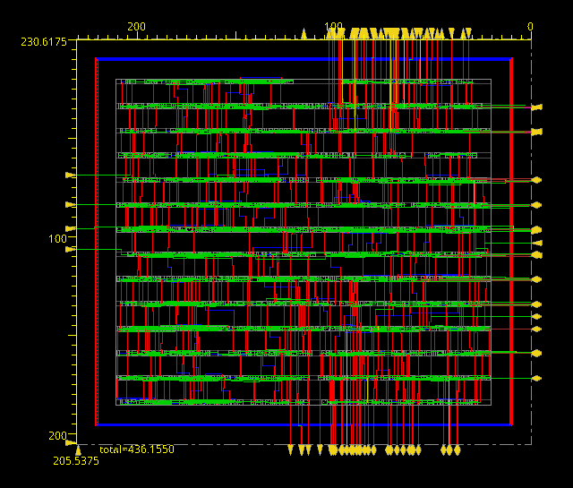
4. Assembly test program used to test your design
MOV R2, 000001111010
MOV R0, 000000000000
MOV R6, 000000010000
MOV R7, 000000000001
ADD R8, R0, R7 LSL R6
ADD R9, R7, R8
MOV R0, 000000000000
STR R2, [R8]
MOV R3, 000000101000
STR R3, [R8]
MOV R4, 000011111111
MOV R5, 000010110111
STR R4, [R8]
STR R5, [R8]
STR R2, [R8]
STR R3, [R8]
STR R4, [R8]
MOV R7, 000000000000
MOV R7, 000000000000
MOV R7, 000000000000
MOV R7, 000000000000
MOV R7, 000000000000
MOV R7, 000000000000
MOV R7, 000000000000
LDR R0, [R9]
MOV R7, 000000000000
LDR R1, [R9]
MOV R7, 000000000000
MOV R7, 000000000000
MOV R7, 000000000000
MOV R7, 000000000000
MOV R7, 000000000000
MOV R7, 000000000000
MOV R7, 000000000000
MOV R7, 000000000000
LDR R2, [R9]
MOV R7, 000000000000
MOV R7, 000000000000
MOV R7, 000000000000
MOV R7, 000000000000
MOV R7, 000000000000
MOV R7, 000000000000
MOV R7, 000000000000
MOV R7, 000000000000
MOV R7, 000000000000
MOV R7, 000000000000
MOV R7, 000000000000
MOV R7, 000000000000
MOV R7, 000000000000
MOV R7, 000000000000
LDR R3, [R9]
MOV R7, 000000000000
MOV R7, 000000000000
MOV R7, 000000000000
MOV R7, 000000000000
MOV R7, 000000000000
MOV R7, 000000000000
MOV R7, 000000000000
MOV R7, 000000000000
MOV R7, 000000000000
MOV R7, 000000000000
MOV R7, 000000000000
MOV R7, 000000000000
MOV R7, 000000000000
MOV R7, 000000000000
LDR R4, [R9]
MOV R7, 000000000000
MOV R7, 000000000000
MOV R7, 000000000000
MOV R7, 000000000000
MOV R7, 000000000000
MOV R7, 000000000000
MOV R7, 000000000000
MOV R7, 000000000000
LDR R5, [R9]
MOV R7, 000000000000
MOV R7, 000000000000
MOV R7, 000000000000
MOV R7, 000000000000
MOV R7, 000000000000
MOV R7, 000000000000
MOV R7, 000000000000
MOV R7, 000000000000
LDR R6, [R9]
END:

